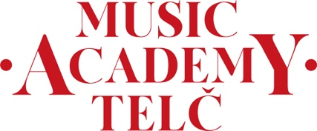

Agreement with with the participation of my daughter/son/ward

Minor students are accepted by the Academy subject to the written informed consent of a parent or guardian (in courses where there is no pedagogical supervision). Students must submit this consent upon arrival. Students will take part in their studies and the Academy programme independently.

I agree with the participation of my daughter/son/ward: …………………………………
in masterclasses at the Music Academy Telč (9th – 18th July 2025), with no pedagogical supervision.

Parent’s or guardian’s full name:

Phone number:

Email address:

Date:

Signature of parent or guardian:

………………………………… …………………………………..

